**Automate VM deployment via Vagrant and Kickstart**

{Example from Linux Administration Cookbook}

Installing a new VM from scratch every time you want to create a VM is boring especially when you find yourself doing that often. Or get tired after the first time.

**Infrastructure as Code (IaC)**

Kickstart Files

Inside CentOS VM: /root/anaconda-ks.cfg

Kickstart files contain setup details that you would have otherwise answered during a manual installation. These files can be edited and then distributed from a web server.

Vagrant

More easily to configure startup files for VMs.

Install Vagrant <https://www.vagrantup.com/downloads.html>

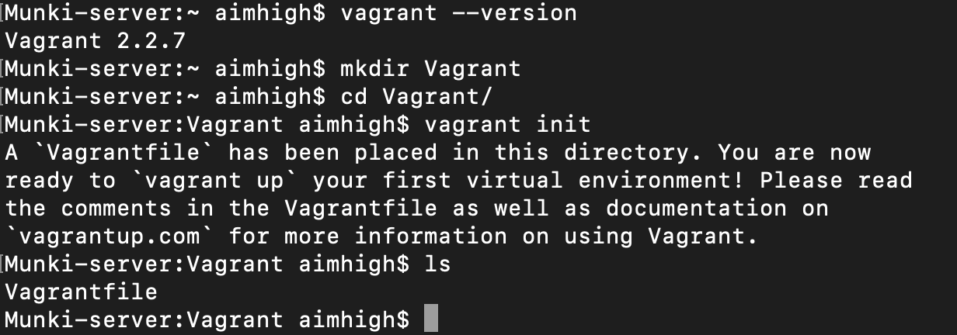

To be continued…with step by step example of setting up Vagrant (with screenshots)